**CODING**

**Back-end code of Object Detection on VS Code**

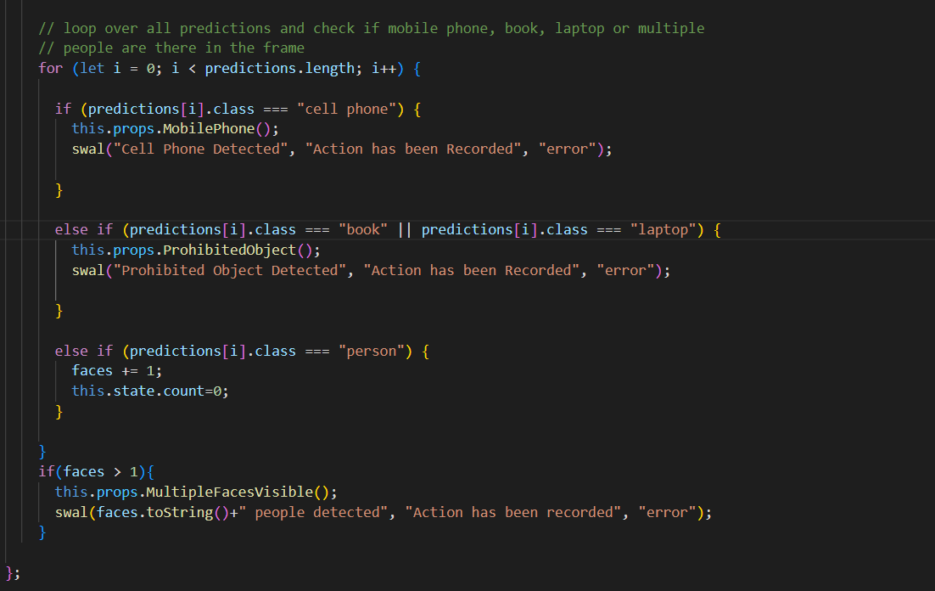

**Back-end code of webcam mount and loading the model**

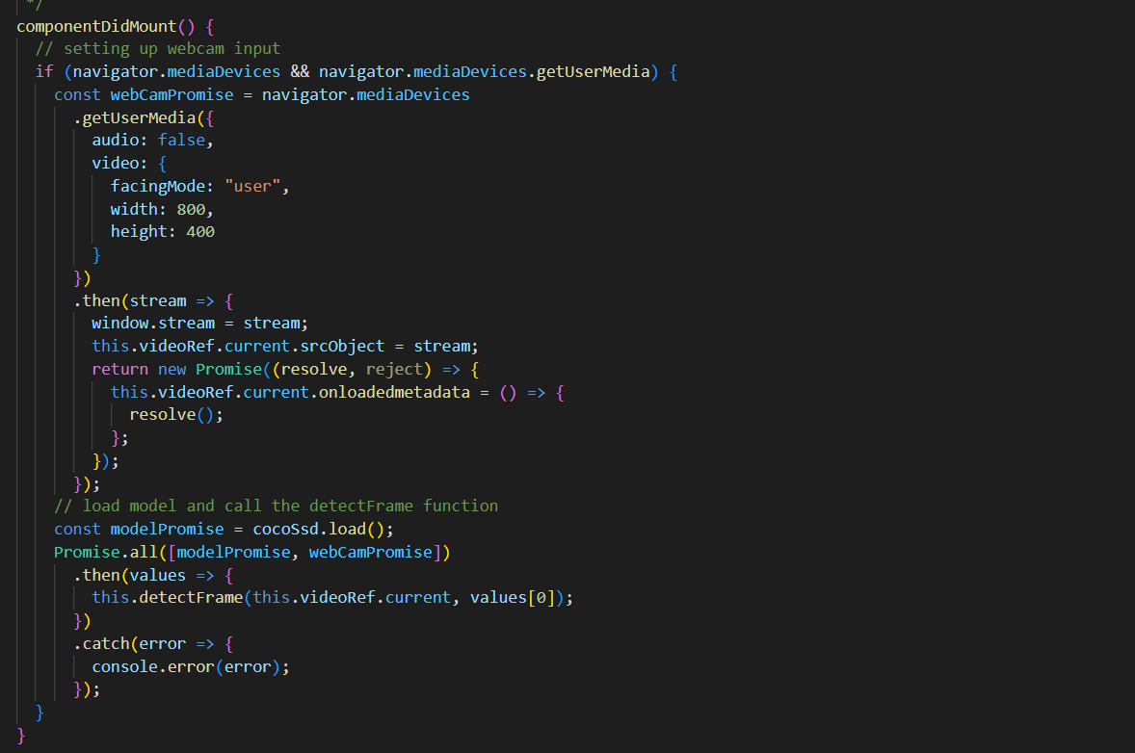

**Back-end code of webcam mount and loading the model**

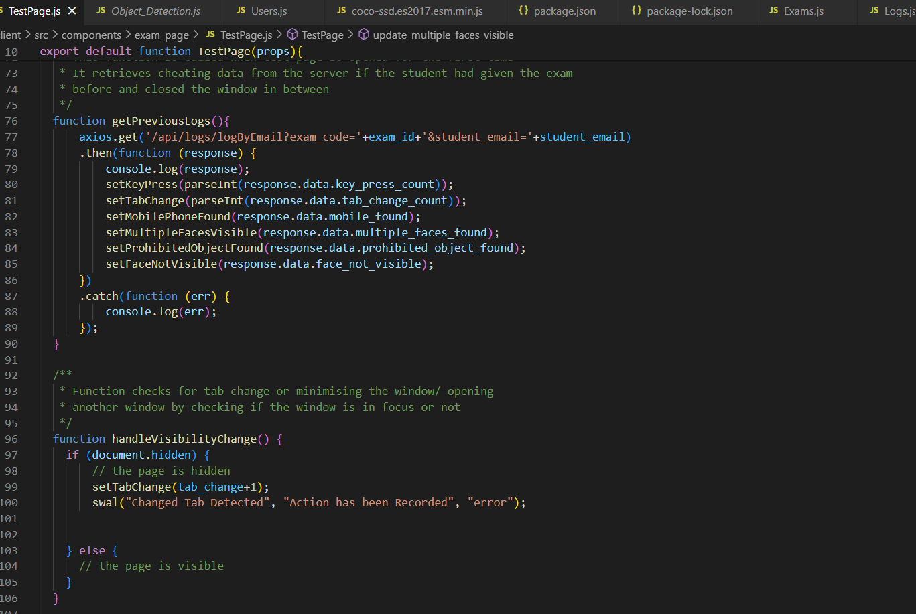

**Back-end code of create exam**

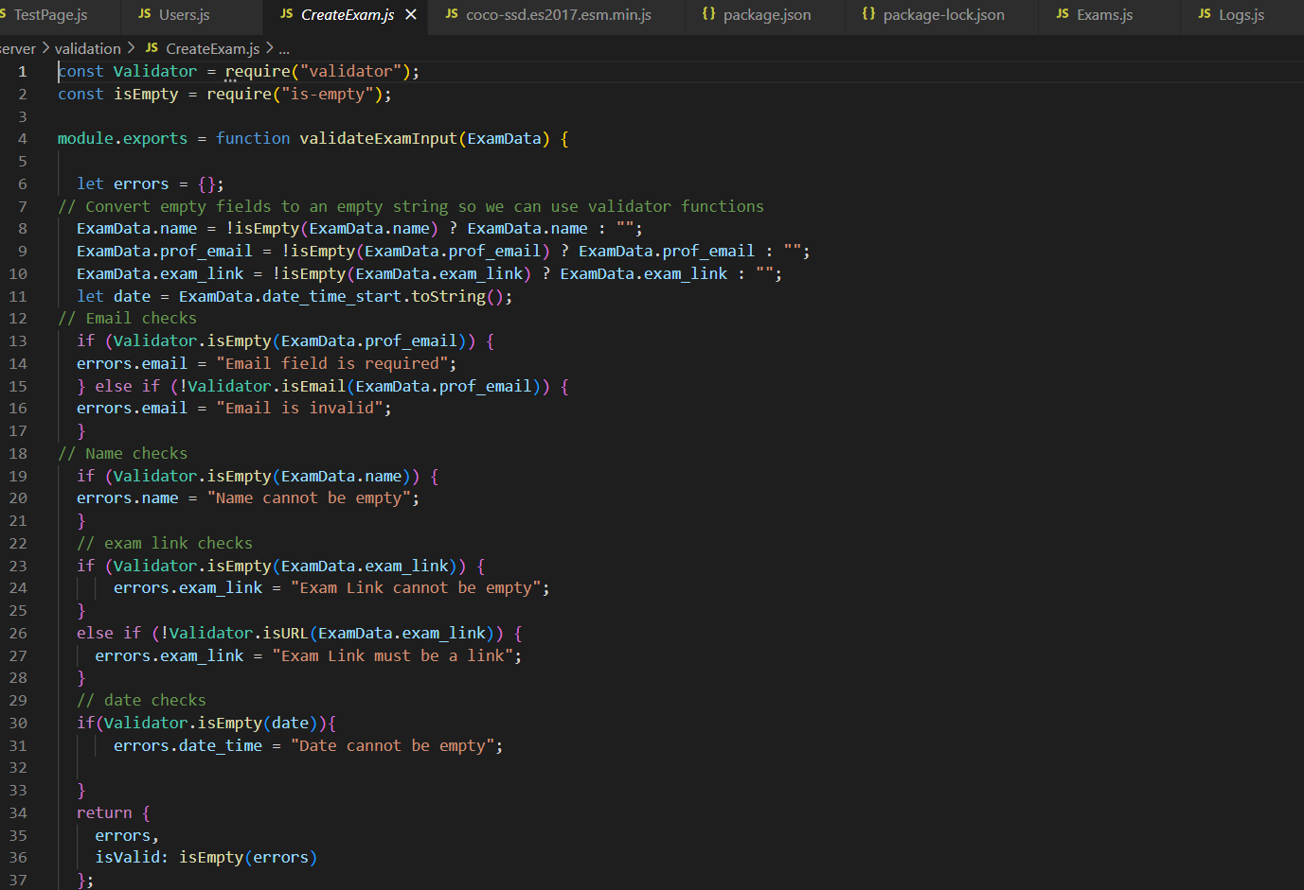

**TESTING**

**Home page:-**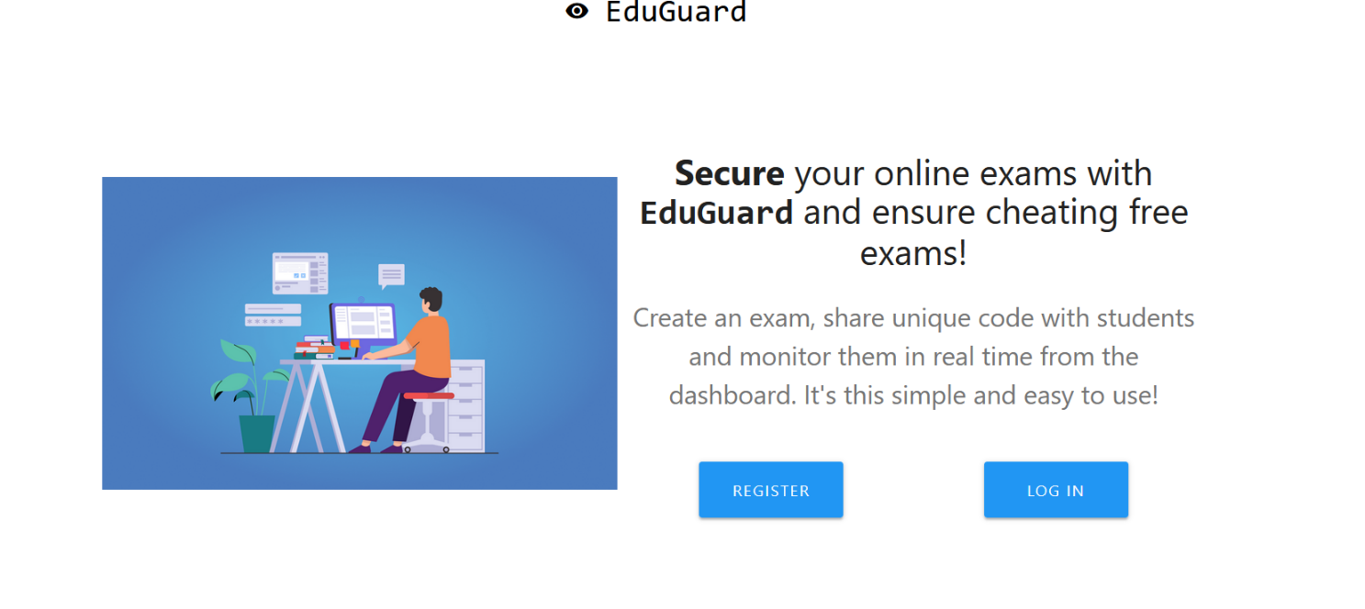

**Registration page:-**

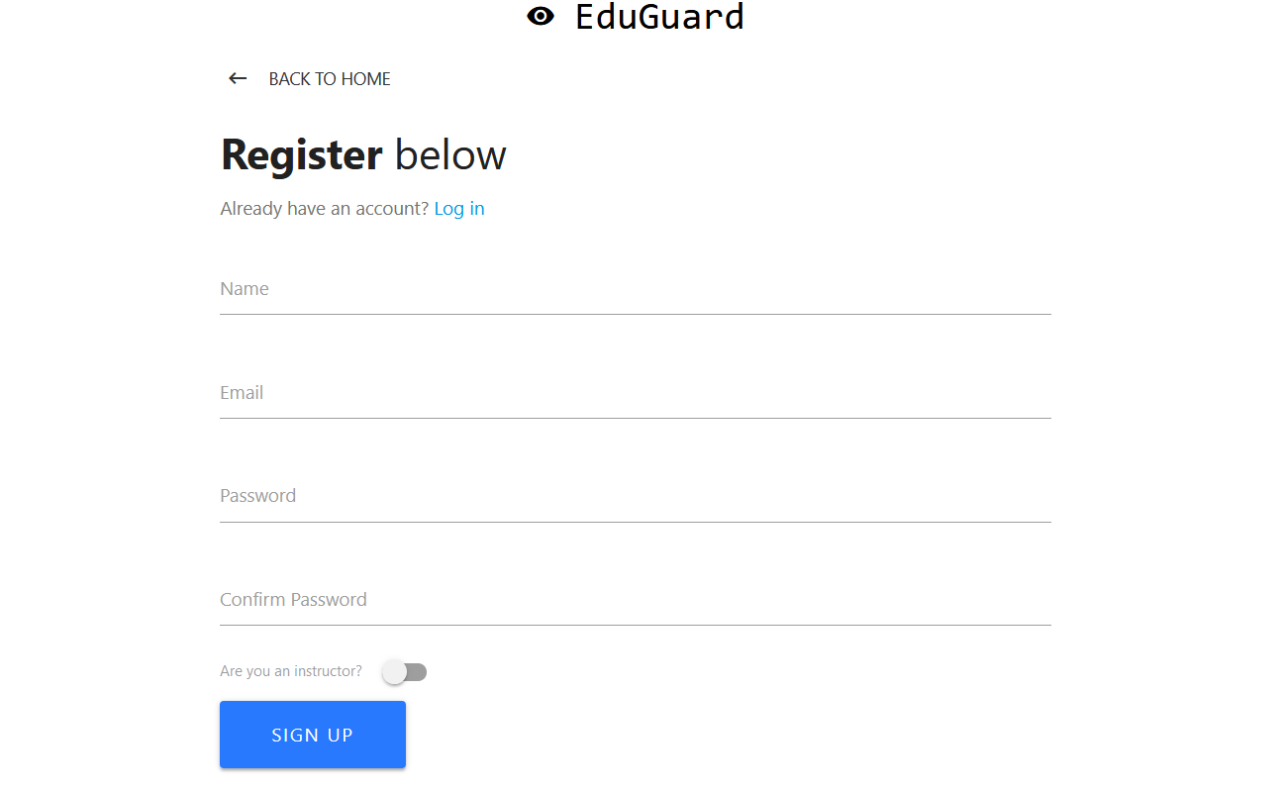

**Login page:-**

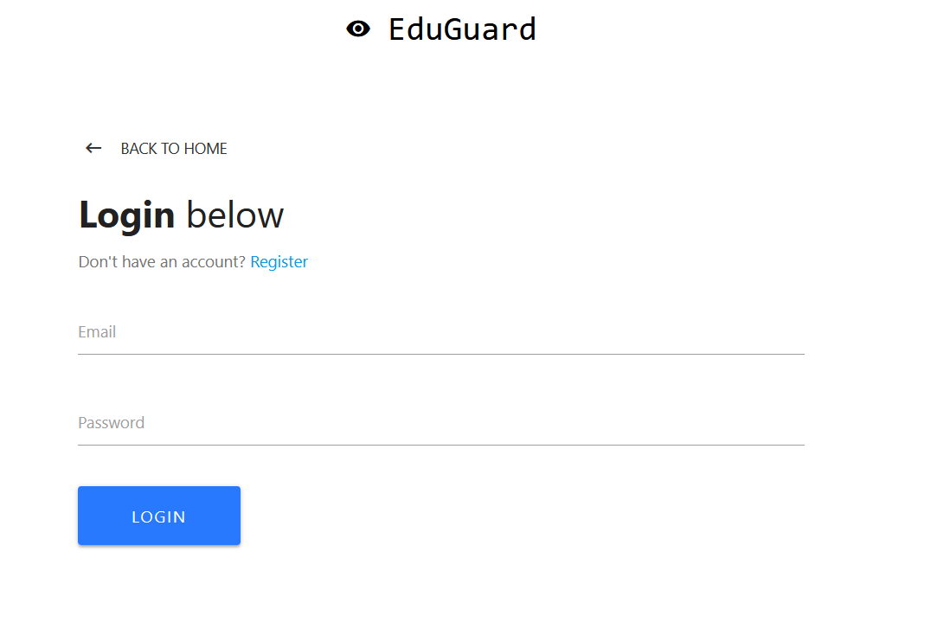

**Webcam access:-**

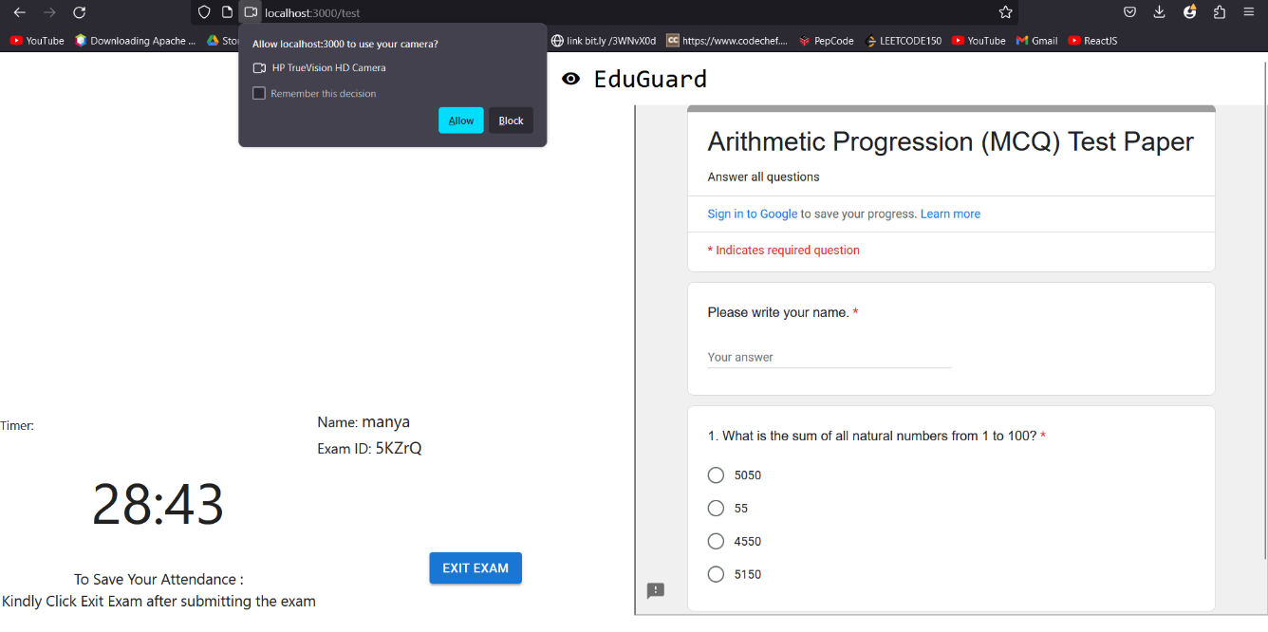

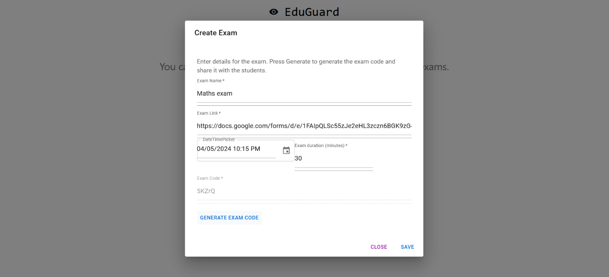**Create Exam page(Professor’s dashboard):**

**Exam page(Student view):**

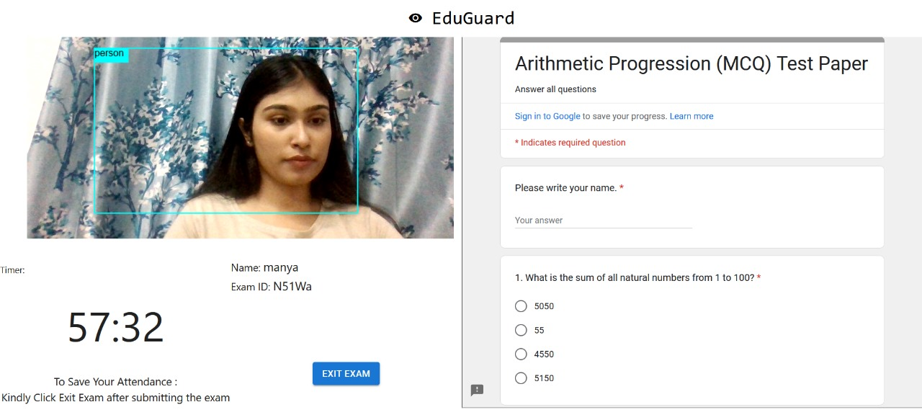

**WARNINGS:-**

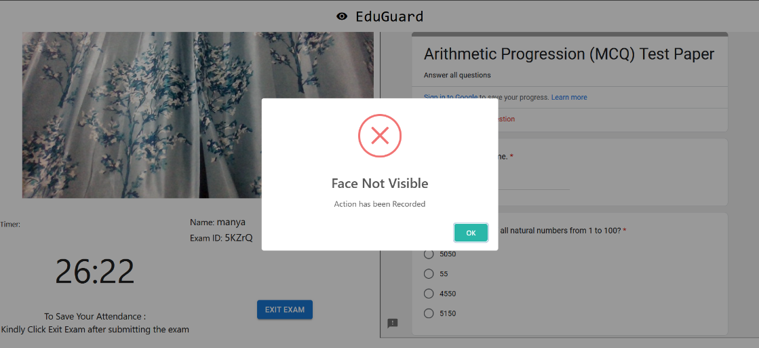

Face Not Visible

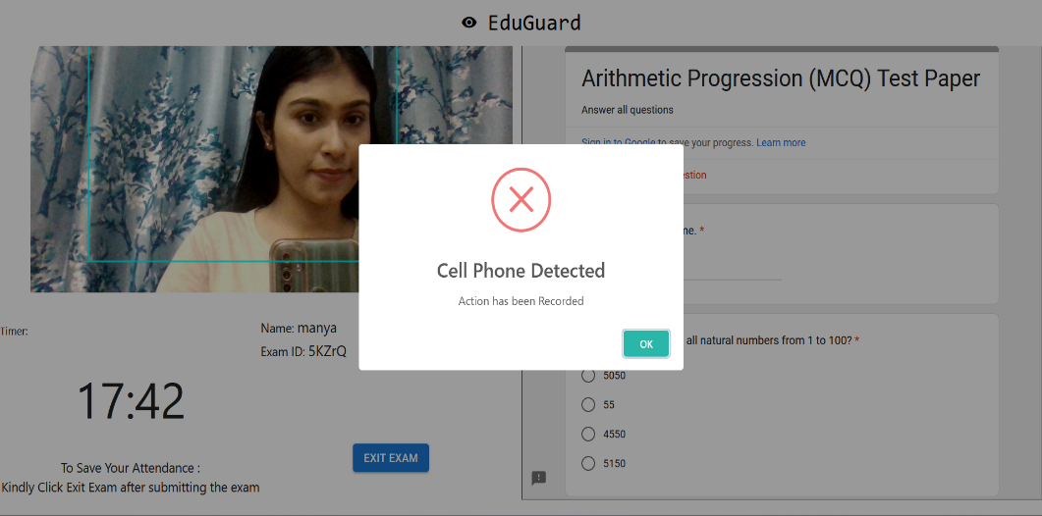

Cell Phone Detection

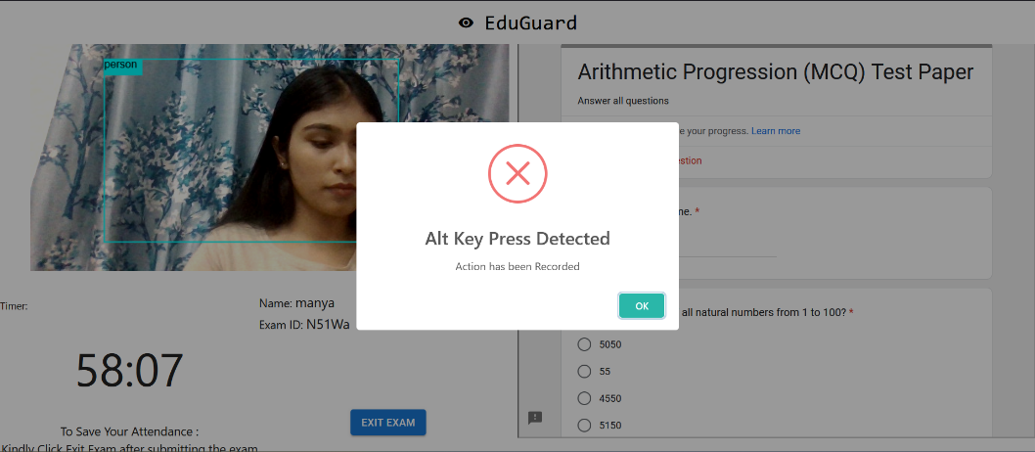

Alt Key Press Detected

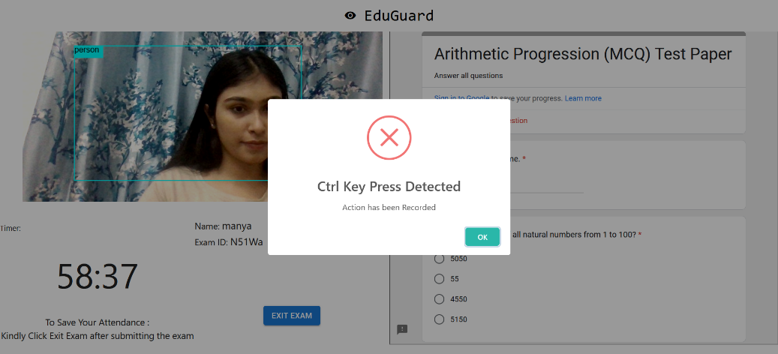

Ctrl Key Press Detected

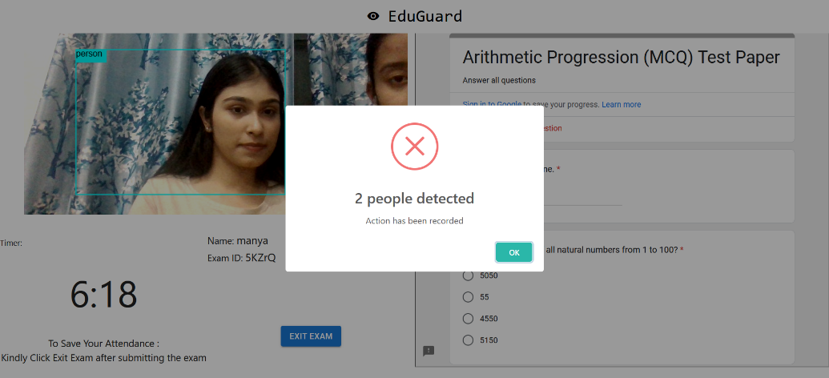

2 people detected

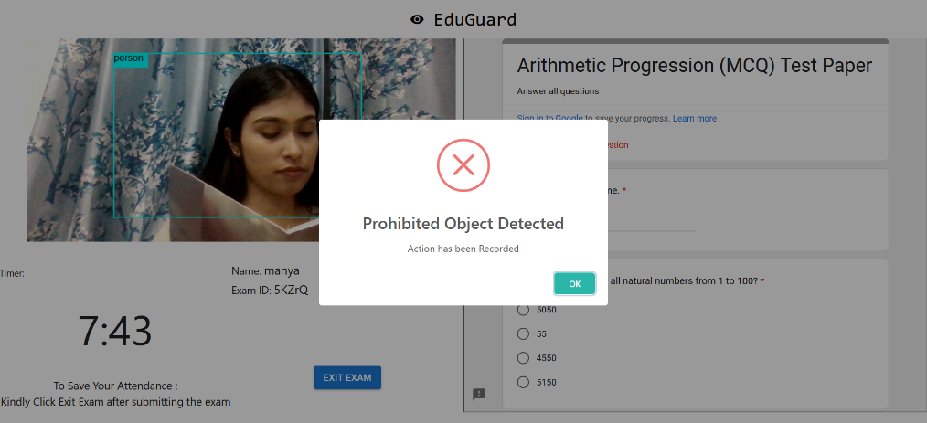

Prohibited Object Detected

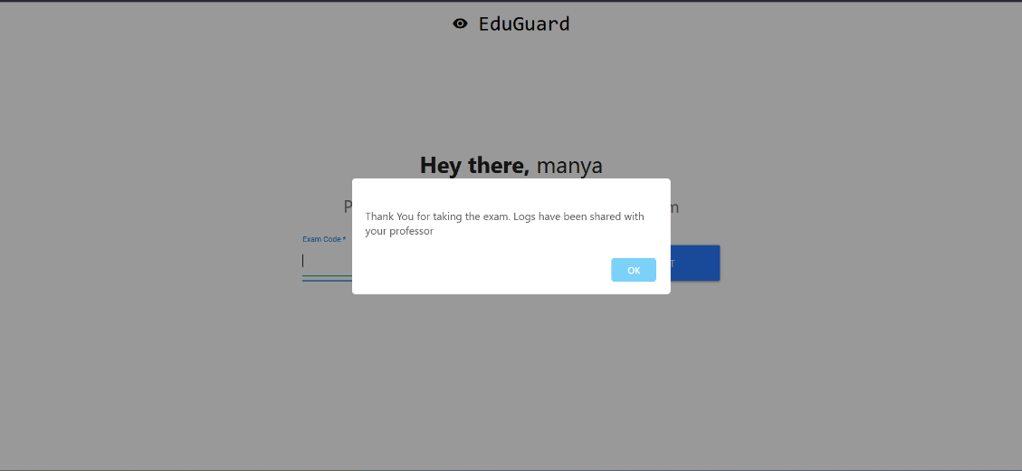

Exit Exam

**PROFESSORS DASHBOARD:-**

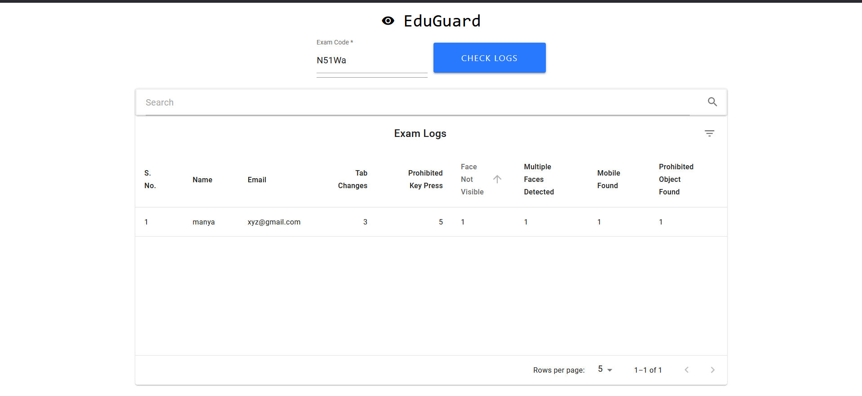

**DATABASE SCHEMA OF STUDENT LOGS [MongoDB]**

const mongoose = require("mongoose");

const Schema = mongoose.Schema;

// create new schema for a student exam log

const LogsSchema = new Schema({

exam_code: {

type: String,

required:true,

},

student_name: {

type: String,

required:true,

},

student_email: {

type: String,

required: true

},

tab_change_count:{

type:Number,

required:true,

default:0,

},

key_press_count: {

type:Number,

required:true,

default:0,

},

mobile_found: {

type:Number,

required:true,

default:0,

},

prohibited_object_found: {

type:Number,

required:true,

default:0,

},

face_not_visible: {

type:Number,

required:true,

default:0,

},

multiple_faces_found: {

type:Number,

required:true,

default:0,

}

}); // export the model

module.exports = User = mongoose.model("logs", LogsSchema);

